**Design Portfolio**

**By:**

**Net 1 Bier**

**Randolph Bock 25905570**

**FJ Fourie 26047799**

Submitted in pursuit of the degree

**BACHELOR OF ENGINEERING**

**In**

**COMPUTER AND ELECTRONIC ENGINEERING**

**North-West -University Potchefstroom Campus**

Supervisor: Prof J. Holm

Potchefstroom

2017

**Contents**

1 System Operational Requirements 1

1.1 Functional Analysis – Operational Level Architecture and Behaviour 1

1.2 Physical Requirements (Form): 4

1.3 Interface requirements(Fit): 4

1.4 Additional Requirements: 5

2 Excel Project management 6

2.1 Combined Project Documents 6

2.1.1 Work Breakdown Allocation 7

2.1.2 Project Schedule 8

2.1.3 Progress tracking 8

2.2 Risk / Mitigation Register 10

2.3 Minutes of Meetings 11

2.4 Randolph Bock 16

2.4.1 Excel Project Management Documents 16

2.4.2 Experience Report 19

2.5 Anton Durandt 20

2.6 FJ Fourie 20

2.6.1 Excel Project Management Documents 20

2.6.2 Experience Report 23

3 Engineering Methods/Skills/Tools: 24

3.1 Randolph Bock 24

3.2 Anton Durandt 24

3.3 FJ Fourie 24

4 Sub-system specification DOCUMENTS: 24

4.1 Randolph Bock 24

4.2 Anton Durandt 24

4.3 FJ Fourie 25

5 Design Documentation: 25

5.1 System Design Documaentation 25

5.1.1 Final System Functional Definition: 25

5.1.2 System concept drawings: 26

5.1.3 System interface Definitions: 27

5.1.4 System integration testing: 30

5.2 Sub-system Design Documentation Randolph Bock: 31

5.2.1 Technology Survey/Datasheets 31

5.2.2 Application Notes 41

5.2.3 Trade off Studies 43

5.2.4 Design Drawings: 44

5.2.5 Behavioural Modelling: 45

5.2.6 Design implementation: 47

5.2.7 Sub-system Test and Evaluation: 48

5.3 Sub-system Design Documentation FJ Fourie: 49

5.3.1 Technology Survey/Datasheets 49

5.3.2 Application Notes 49

5.3.3 Trade off Studies 50

5.2.4 Design Drawings: 51

5.2.5 Behavioural Modelling: 53

5.2.6 Design implementation: 53

5.2.7 Sub-system Test and Evaluation: 56

**List of Figures:**

Figure 1: System Operational Architecture 2

Figure 2: System Operational Flow 3

Figure 3: Back end initial screen concept 51

Figure 4: Admin login screen concept 52

Figure 5: Incident display screen concept 52

Figure 6: Back end initial screen 54

Figure 7: Admin login screen 54

Figure 8: Incident display screen 55

**List of Tables:**

Table 1: Work Breakdown and Allocation 7

Table 2: Project Schedule 8

Table 3: Progress tracking 9

Table 4: Risks and Mitigations 10

Table 5: Timeline of Randolph Bock 18

Table 6: Timeline of FJ Fourie 22

**List of abbreviations:**

* FSM – Finite State Machine
* UDP – User Datagram Protocol
* OS – Operating System
* SoC – System on Chip
* SBC – Single Board Computer.
* DCS – Door Contact Switch

# 1 System Operational Requirements

## 1.1 Functional Analysis – Operational Level Architecture and Behaviour

1.1.1 System Operational Architecture:

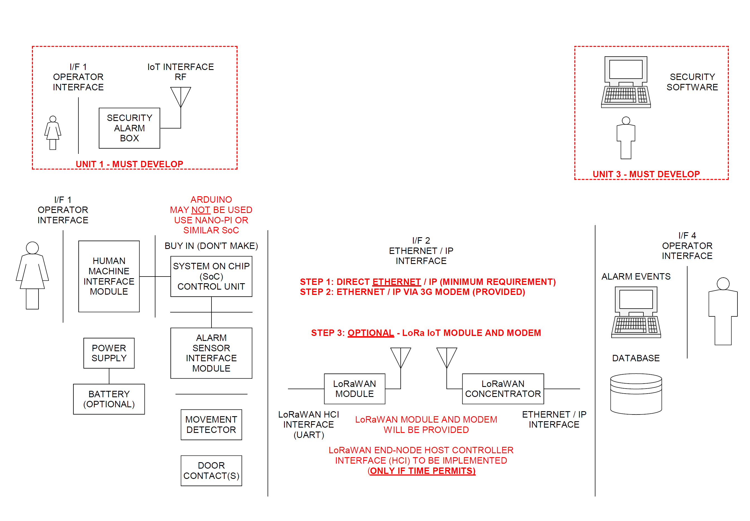

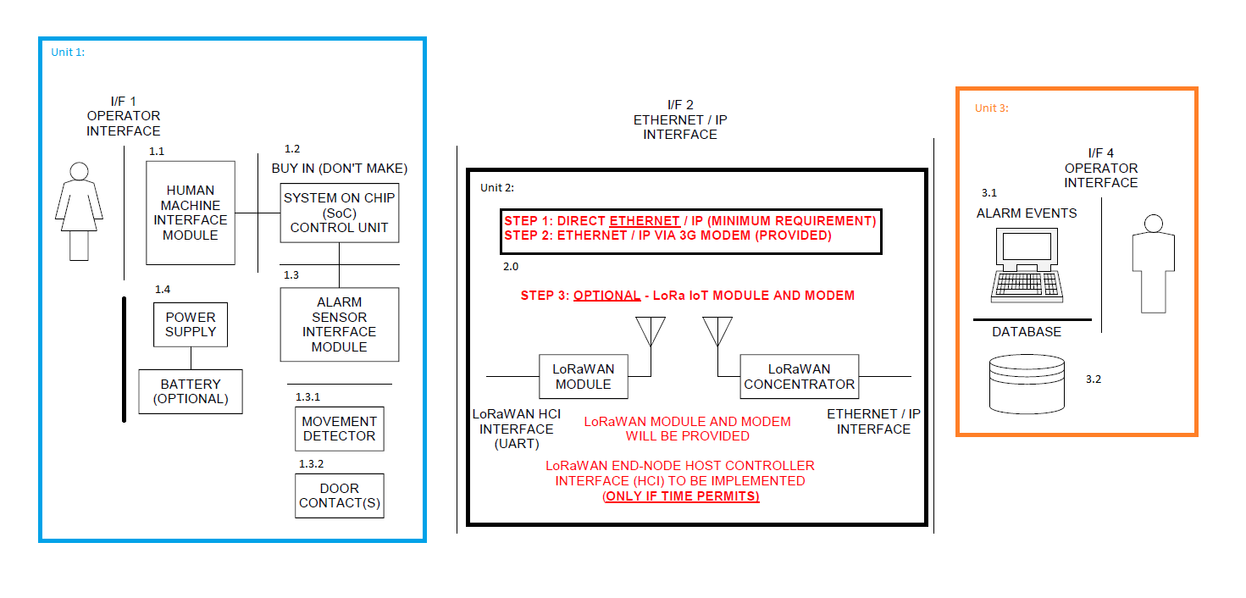

Figure : System Operational Architecture

1.1.2 System Operational Flow:

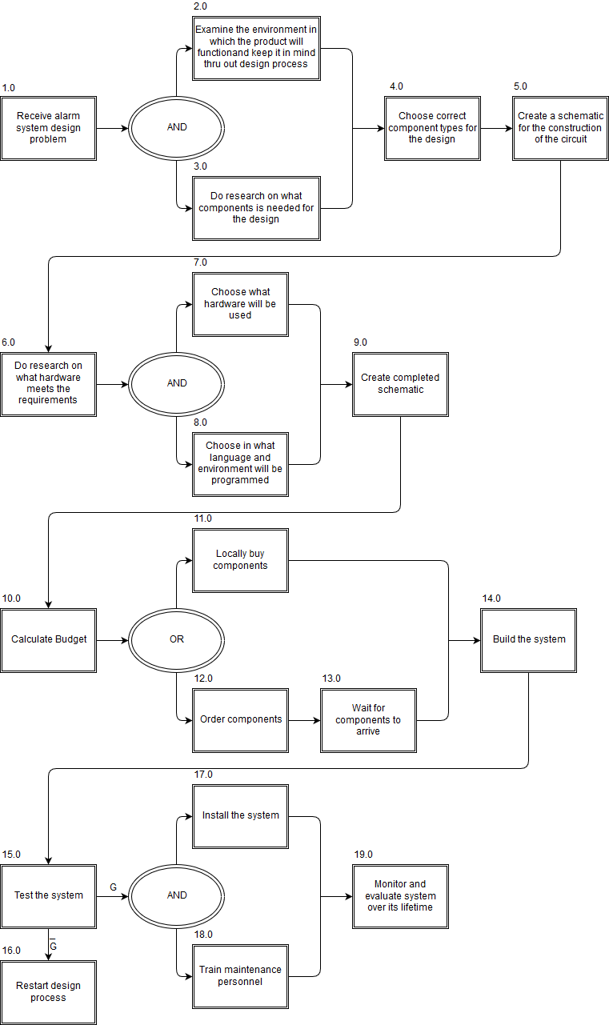

Figure : System Operational Flow

## 1.2 Physical Requirements (Form):

* The alarm panel as well as any sensors of the system must be IP54 rated.
* The alarm panel must be wall mountable
  + The Design must not exceed 0.5Kg as to be easily wall mountable
* Unit should not protrude at strange angles that will cause harm to people passing by. All edges must be smooth to the touch, with no sharp object on the unit to cut/hurt.
* Functional shape that will fit into any home without inconvenience
* Size of unit must not be to large
  + 1m x 1m x 0,5m size constraint
* The alarm panel must allow for wires to enter the panel without damaging the wires. A rubber grommet is used to protect wires extruding from the unit.
* The placement on the wall cannot be too high as it will make it difficult for users to access the panels 1.6 meter from floor level is recommended, this can be varied for specific user use.
* The placement cannot be to low either as it may become a risk for small children, placement must be more than 1 meter from floor level
* The placement should not be over pre-existing water pipes or wiring in the wall

## 1.3 Interface requirements(Fit):

* The interface between the end user and the alarm will be both audio and visual, and be easily understandable (I/F 1.1)
* All items on the functional architecture must be developed, apart from PIR and other sensors (I/F 1.4)
* The single board computer (SBC) will be a Raspberry Pi
* An output will be provided to the Power Block to show that motion has been detected on an “outdoor sensor”
* The input power to the Alarm Panel will be provided from the Power Block and will be 12V at a maximum of 6W (I/F 1.5)
* The interface between the incoming power and the internal power supply of the system will be a two-wire interface, positive and negative wire, to be connected to the system with screw in wire terminals. (I/F 1.5)
* The Alarm Panel will provide its own internal voltages for the SBC and other components (Unit 1.4)
* The network communication between the Alarm panel and the backend-server is to be done with a direct ethernet connection or a WIFI connection (I/F 2)
* The database server will initially be hosted on a laptop or PC.

## 1.4 Additional Requirements:

1.4.1 Environmental Requirements:

* The alarm panel as well as any sensors of the system must be IP54 rated
* Dust proof rating of 5, Limited protection against dust ingress. (no harmful deposit)
* Water resistant rating of 4, Protected against splash water from any direction.
* Temperature requirement of -5°C to 40°C
* Will be made reasonably tamper proof. Wires are tied down internally to prevent the destruction of internal component when the extruded wires are being tampered with.
* The Alarm panel is to be serviceable with the use of a key to open the unit. Key will only be available to trained technicians.
* Will be made from strong material to endure some wear a metal chassis is to be used for the alarm panel
* The system must be protected against Electro Static Discharges, ESD.

1.4.2 Safety requirements

* The system will be grounded to ensure no electrical shocks can occur to an end user
* No open wires
* Not accessible to children
* Closed box so that people who do not understand the device cannot tamper with it
* Reasonably tamper proof

1.43 Legislative Requirements (SAIDSA bylaw 25)

* Control equipment
  + Control panel installed min of 1.5 m form ceiling
  + Digital keypads must be of the data transfer technology type
  + Disarming delay no more than 30 seconds
* Signalling equipment
  + Signalling equipment will be positioned within the protected area
  + Not placed where telephone lines are vulnerable
* Maintenance
  + Inspect and test each detection device back to control panel
  + Inspecting alarm panel and transmitter
  + Inspect cables for visible damage

1.4.4 Usability Requirements:

* System must be easily operated with minimal training required to operate the system
* Compensation for mounting will be made for the control box

# 2 Excel Project management

## 2.1 Combined Project Documents

The following documentation has been taken and adapted from the project management excel document.

### 2.1.1 Work Breakdown Allocation

In the following Table 1 the work allocation for each member is documented. This work allocation was done at the start of the project and as new work may arise or some work may prove to be more difficult than thought or some work may be found to be very easy this list will be adjusted accordingly.

Table : Work Breakdown and Allocation

|  |  |
| --- | --- |
| **Member** | **Work allocation** |
| Randolph Bock | * Design circuit for security inputs (Including Door switches and PIR's) * Design circuit for output siren (to be run on 12v) * Design and implement a user interface * Design and code the SoC to handle all inputs and outputs * Order parts * Trade-off decisions * Assemble the final unit 1 as a whole * Design and implement a Direct Ethernet / IP connection between SoC and Pc * Design and implement an Ethernet / IP connection via 3g between SoC and Pc |
| FJ Fourie | * Design database for information of users and alarm systems * Design backend operator interface * Write program for backend of system to manage alarms going off and instruct operators on what to do * Integrate backend program with database * Ensure operator interface works correctly with signals received from web * Assemble the final complete project * Designing and implementing the backend communications to the SoC |

### 2.1.2 Project Schedule

Below in Table 2 the timeline for the project is documented as decided upon at the start of the project.

Table : Project Schedule

|  |  |
| --- | --- |
| **Date** | **Description** |
| **17-Jul-17** | **Project Initiation** |
| **10-Aug-17** | **Functional Analysis Test** |
| **14-Aug-17** | **Preliminary Design Complete** |
| **31-Aug-17** | **30% Completion Milestone** |
| **30-Sep-17** | **50% Completion Milestone** |
| **27-Oct-17** | **80% Completion Milestone** |
| **10-Nov-17** | **100% Completion Milestone** |
| **16-Nov-17 to 17-Nov-17** | **Demonstration** |

### 2.1.3 Progress tracking

We use a RAG status to track the progress of the project each week with descriptions for when the project falls into the amber or red regions. This is all shown below in Table 3.

Table : Progress tracking

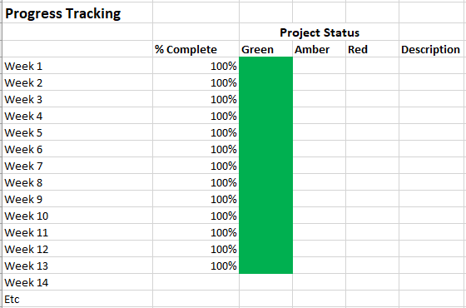

## 2.2 Risk / Mitigation Register

Table : Risks and Mitigations

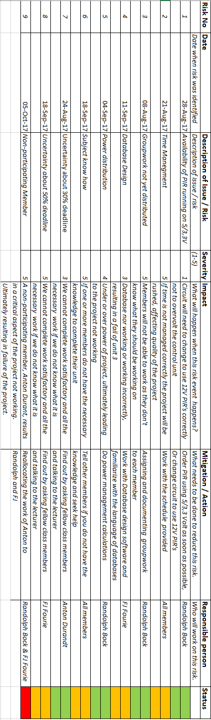

## 2.3 Minutes of Meetings

The following are the minutes of all the meetings held by the group.

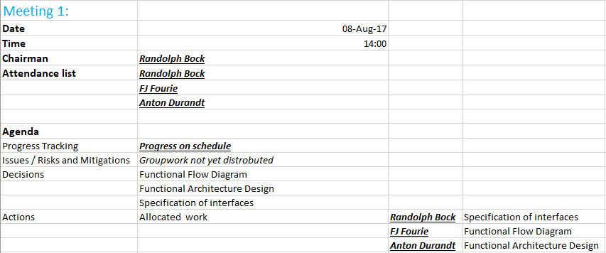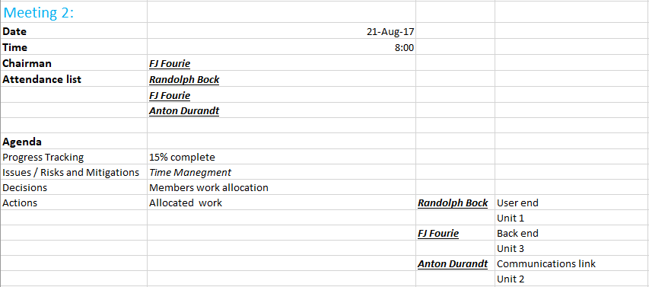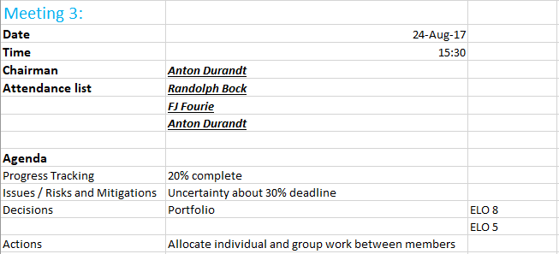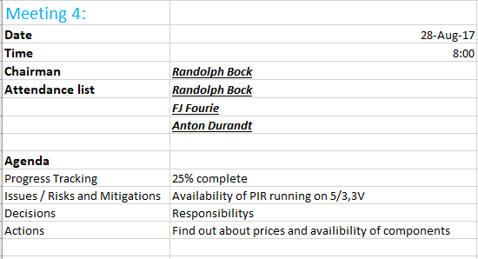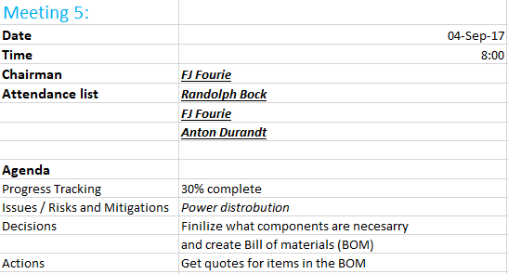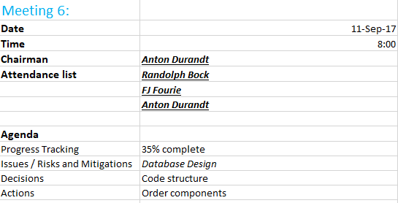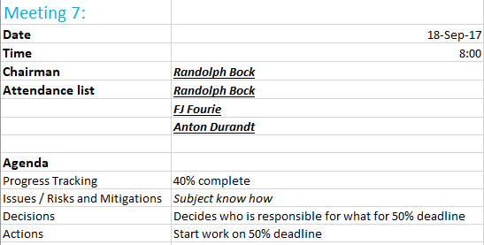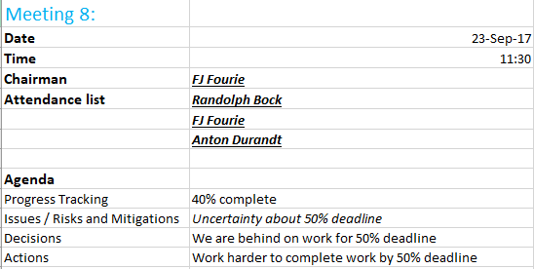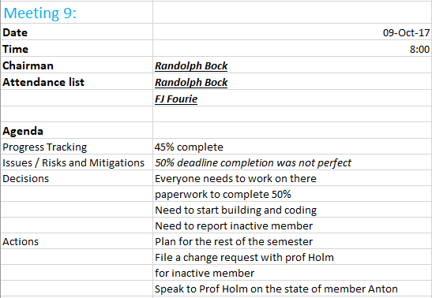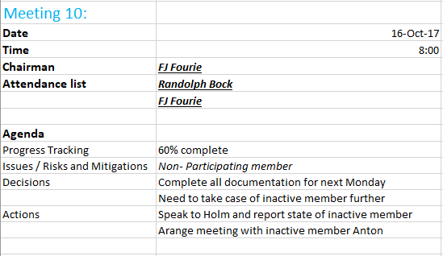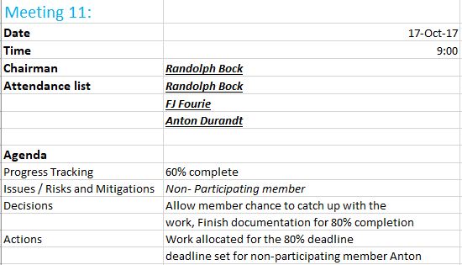

## 2.4 Randolph Bock

### 2.4.1 Excel Project Management Documents

#### 2.4.1.1 Expertise

* Software
* Hardware
* Documentation

#### 2.4.1.2 Parts of the project the member is responsible for

#### 2.4.1.3 Unit Breakdown:

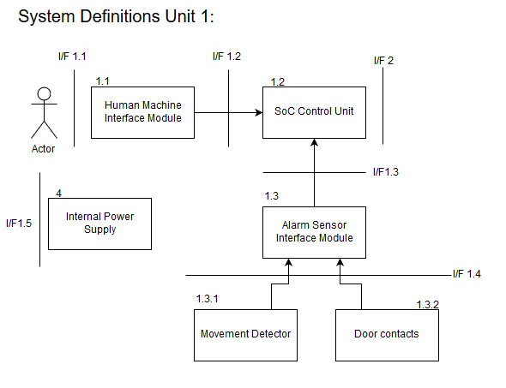

#### 2.4.1.4 Work Breakdown

* Design circuit for security inputs (Including Door switches and PIR's)
* Design circuit for output siren (to be run on 12v)
* Design and implement a user interface
* Design and code the SoC to handle all inputs and outputs
* Order parts
* Trade-off decisions
* Assemble the final unit as a whole

#### 2.4.1.5 Timeline

Table : Timeline of Randolph Bock

|  |  |
| --- | --- |
| **Date** | **Description** |
| **17-Jul-17** | **Project Initiation** |
| **10-Aug-17** | **Functional Analysis Test** |
| **14-Aug-17** | **Preliminary Design Complete** |
| **31-Aug-17** | **30% Completion Milestone** |
| **30-Sep-17** | **50% Completion Milestone** |
| **7-Oct-17** | **Design of inputs and outputs Unit 1** |
| **14-Oct-17** | **Code and implementation on SoC** |
| **20-Oct-17** | **Final assembly of Unit 1** |
| **27-Oct-17** | **80% Completion Milestone** |
| **10-Nov-17** | **100% Completion Milestone** |
| **16-Nov-17 to 17-Nov-17** | **Demonstration** |

#### 2.4.1.6 Progress Tracking

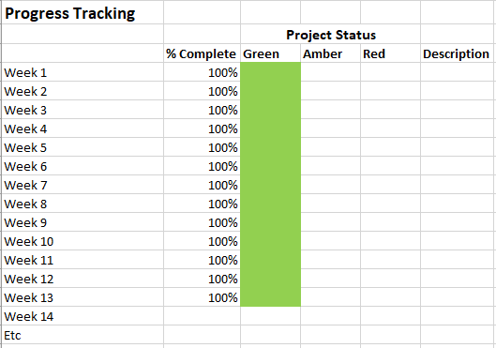

### 2.4.2 Experience Report

Myself and two other members has been tasked to design and implement an alarm system for our third years project. The project was divided into 3 units, each member will be responsible for their own unit. The units consist of the physical Alarm Panel, communications, and back-end server. Unit 1 has been allocated to me as I had the most experience in hardware solutions.

The task was daunting at first, but after doing research and determining the requirement, the task then seemed doable within the given timeframe.

Skills required for the task of design Unit 1 the alarm panel is electronic knowledge for the electrical connection required. Programming knowledge to write the embedded system program, as well as knowledge of the Linux operating system distribution, “Raspbian”.

## 2.5 Anton Durandt

Member missing in action.

## 2.6 FJ Fourie

### 2.6.1 Excel Project Management Documents

#### 2.6.1.1 Expertise

* Software
* Documentation
* Databases

#### 2.6.1.2 Parts of the project the member is responsible for

* I/F 4 Operator Interface
* I/F 3 Cloud Interface
* I/F 5 Cellular Network

#### 2.6.1.3 Unit Breakdown

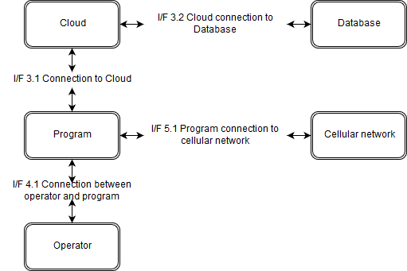

#### 2.6.1.4 Work Breakdown

* Design database for information of users and alarm systems
* Design backend operator interface
* Write program for backend of system to manage alarms going off and instruct operators on what to do
* Integrate backend program with database
* Ensure operator interface works correctly with signals received from web
* Assemble the final complete project

#### 2.6.1.5 Timeline

Table : Timeline of FJ Fourie

|  |  |
| --- | --- |
| **Date** | **Description** |
| **17-Jul-17** | **Project Initiation** |
| **10-Aug-17** | **Functional Analysis Test** |
| **14-Aug-17** | **Preliminary Design Complete** |
| **31-Aug-17** | **30% Completion Milestone** |
| **30-Sep-17** | **50% Completion Milestone** |
| **7-Oct-17** | **Design database and program for Unit 3** |
| **14-Oct-17** | **Write program and integrate program with database** |
| **20-Oct-17** | **Final assembly of Unit 3** |
| **27-Oct-17** | **80% Completion Milestone** |
| **10-Nov-17** | **100% Completion Milestone** |
| **16-Nov-17 to 17-Nov-17** | **Demonstration** |

#### 2.6.1.6 Progress Tracking



### 2.6.2 Experience Report

In 2017 which is my 3rd year of studying I have been put into a team of 3 students to complete a project. The project that has been allocated to us is that of an alarm security system we must design and construct the entire system. The project was divided into 3 major units with each member being tasked with completing a unit. The first unit is the alarm panel and user end of the system, the second unit is the communication of the first unit with third unit over the cellular network. The third unit of this project is the backend program that will be connected to a database in the cloud and will be manned by an operator, this is the unit I have been given and tasked with completing. I went about completing this task by firstly identifying all the requirements and individual parts of my unit after which I started researching each component in an attempt to find the best possible solution for each requirement. Through my research and eventual completion of the unit have I broaden my knowledge of the fields of telecommunication, databases, programming and cloud hosting. This has also been a great opportunity for me to have grown as an engineer and thru this process I have grown my skills and abilities in these fields, my knowledge and abilities with the QT programming environment have increased drastically as well as my capabilities in the C++ programming language. I have also learnt a lot about Databases learning to use the program and tools provided by MYSQL to create and host databases. This was also a great opportunity to increase my understanding and abilities with transmission of data over a wireless network using different protocols some of which are existing protocols and others which we designed ourselves. I have also gotten a much broader understanding of the engineering process and all the documentation involved with it as well as all the additional tools used before starting the actual building or programming of the project such as using functional analysis. I have also increased my abilities to work in a team and have learned a lot of important team skills that will be necessary in the work place one day.

# 3 Engineering Methods/Skills/Tools:

## 3.1 Randolph Bock

See additional Document: Design 2017 - Randolph ELO5 - Net1Bier.docx

## 3.2 Anton Durandt

Member missing in action.

## 3.3 FJ Fourie

See additional Document: Design 2017 - FJ ELO5 - Net1Bier.docx

# 4 Sub-system specification DOCUMENTS:

## 4.1 Randolph Bock

See additional Document: Design 2017 - Randolph Sub-System-specification-Document-Net1Bier.docx

## 4.2 Anton Durandt

Member missing in action.

## 4.3 FJ Fourie

See additional Document: Design 2017 - FJ Sub-System-specification-Document-Net1Bier.docx

# 5 Design Documentation:

## 5.1 System Design Documaentation

### 5.1.1 Final System Functional Definition:



### 5.1.2 System concept drawings:

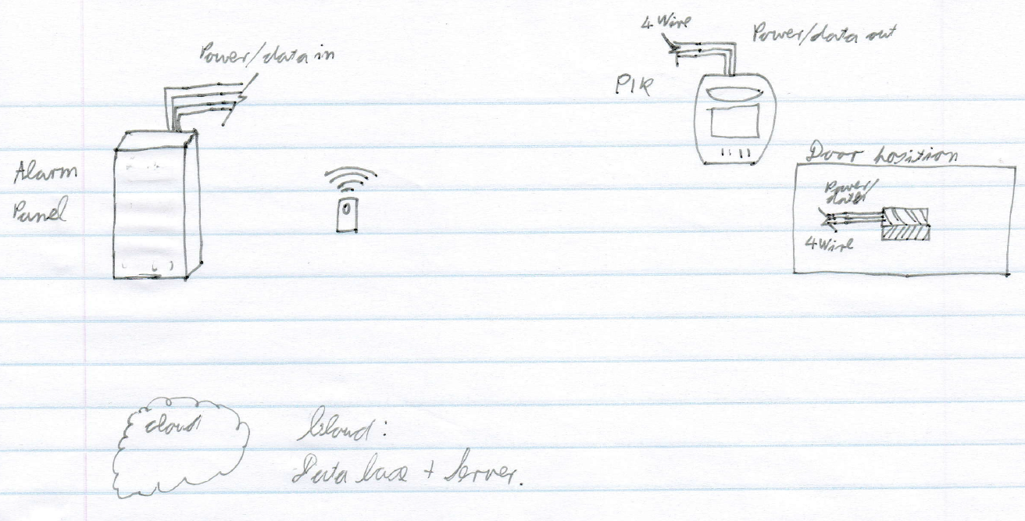

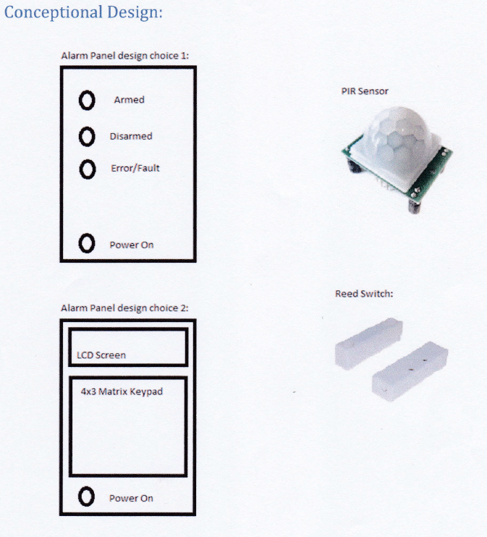

### 5.1.3 System interface Definitions:

**Interface control document (I/F 1.5)**

This interface control document is the interaction between the power block and the alarm.

I/F 1.5

Power block

Alarm Panel

**Electrical requirements**

The power block will provide 12 V and 6 W power to the alarm panel.

**Mechanical requirements:**

The mechanical interface will be a two-point screw terminal for both sides so that a wire can be connected between the two.

This document was signed in Potchefstroom on the date 2017/09/4 as an agreement between the EERI327/ INEM327 and REII327 students regarding the power supply to the alarm panel. This document is binding until the end of the 3rd year design module 2017.

Representatives

_________________________________

**C.F. Greyling**

_________________________________

**FJ Fourie**

Witnesses

_____________________________

**Witness 1**



_________________________________

**Witness 2**

**Interface control document (I/F 2):**

This interface control document is the network interaction between the Alarm panel and the Back-end security software.

**Network requirements:**

Transmission Control Protocol, TCP, to be used to send data from Panel to backend services.

**For network connection:**

1. The Alarm panel will send out a broadcast command over User Datagram Protocol, UDP. (Port 7000)
2. The Back-end server will then send it’s IP over UDP to the alarm panel
3. A TCP Connection will be set-up between the server and the alarm panel. (Port 7000)
4. Communications will then take place according to the protocol requirements below

Protocol requirements:

Protocol payload fields:

|  |  |  |  |  |  |
| --- | --- | --- | --- | --- | --- |
| Protocol ID (‘1B’) | Client ID | Date | Time | Section code | Parity |

The payload fields will be “#” separated.

### 5.1.4 System integration testing:

|  |  |  |
| --- | --- | --- |
| Action | Expected Results | ✓/🗶 |
| Trigger Alarm | Message sent through network to PC |  |
| Read from Database | Read specific data from database to PC |  |

## 5.2 Sub-system Design Documentation Randolph Bock:

### 5.2.1 Technology Survey/Datasheets

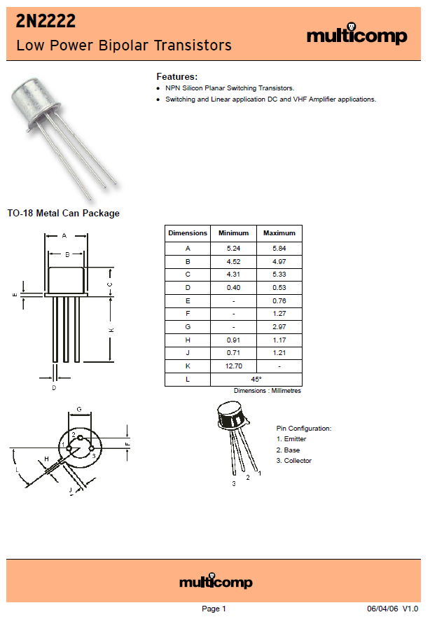

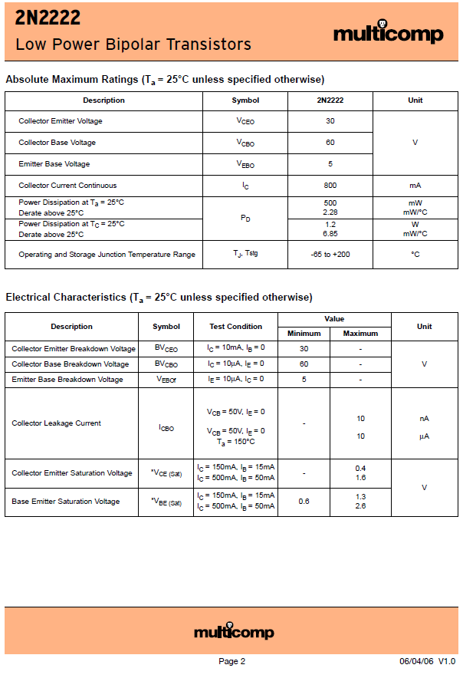

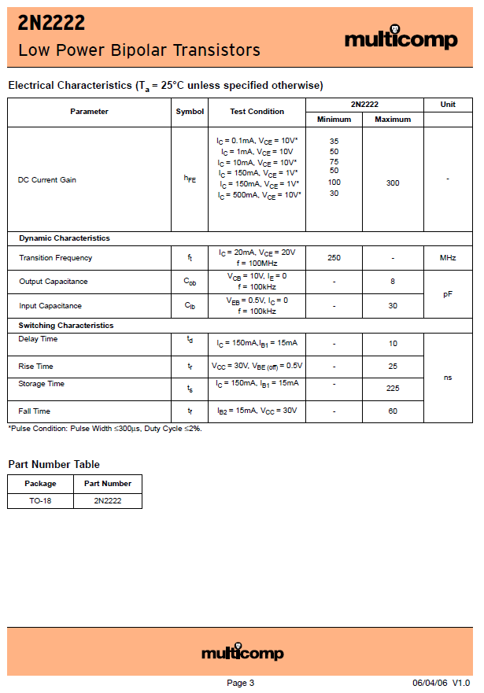

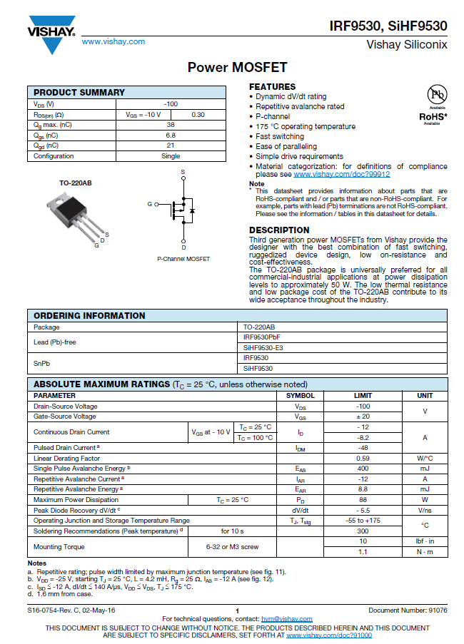

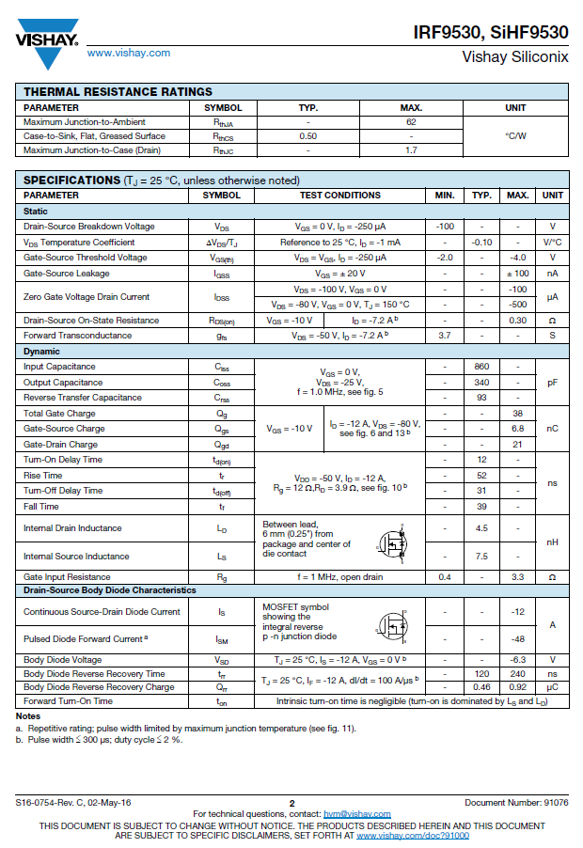

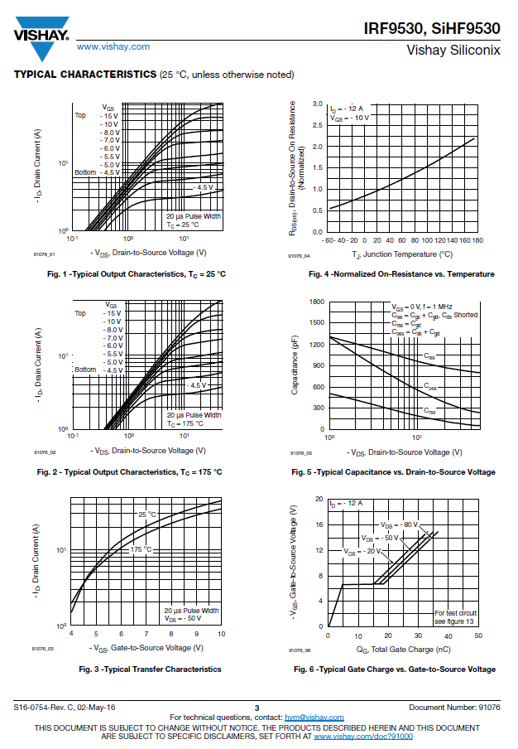

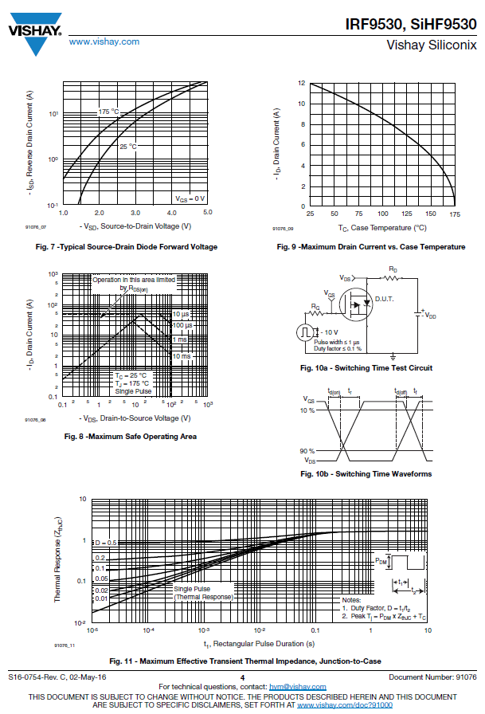

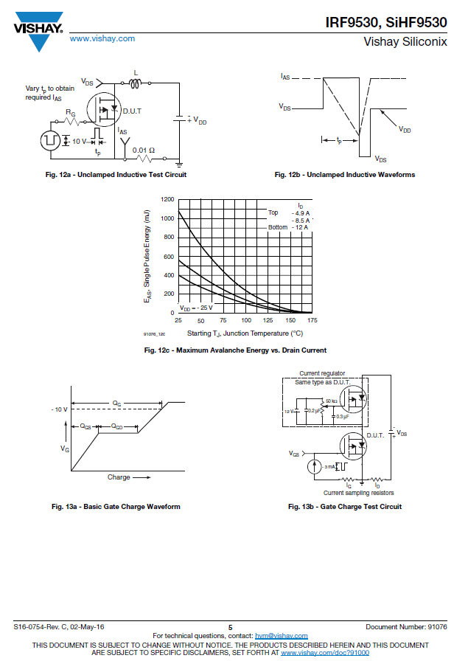

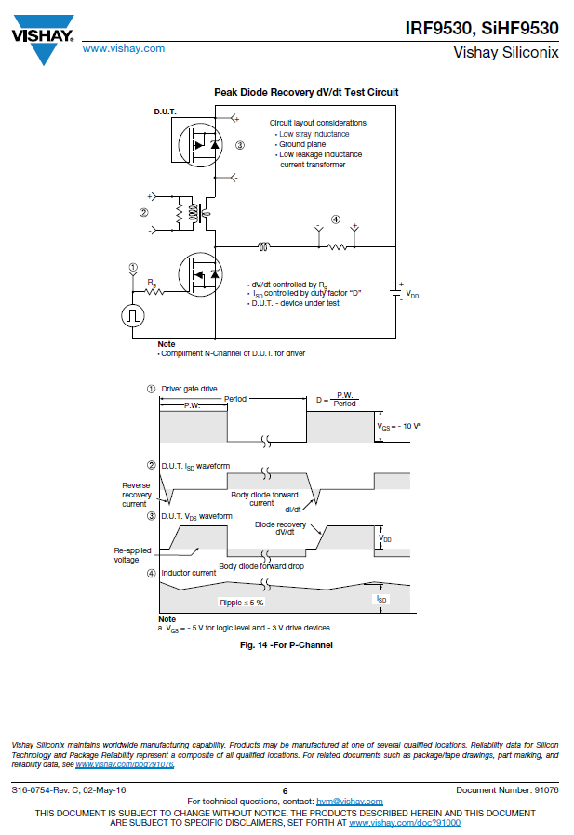

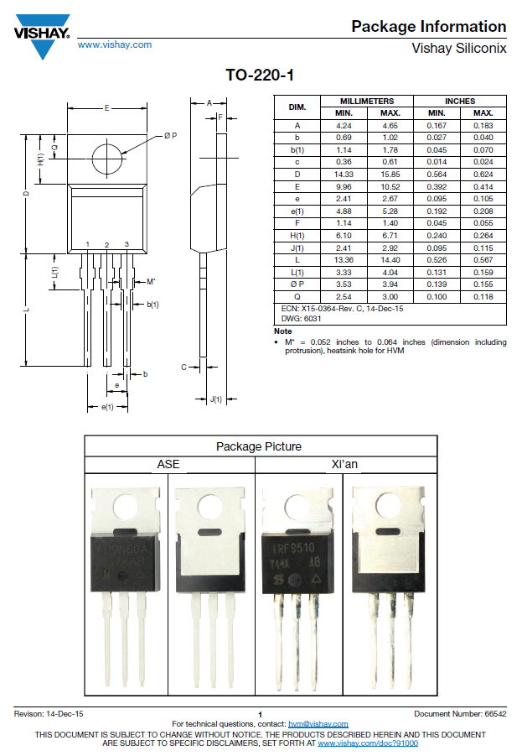

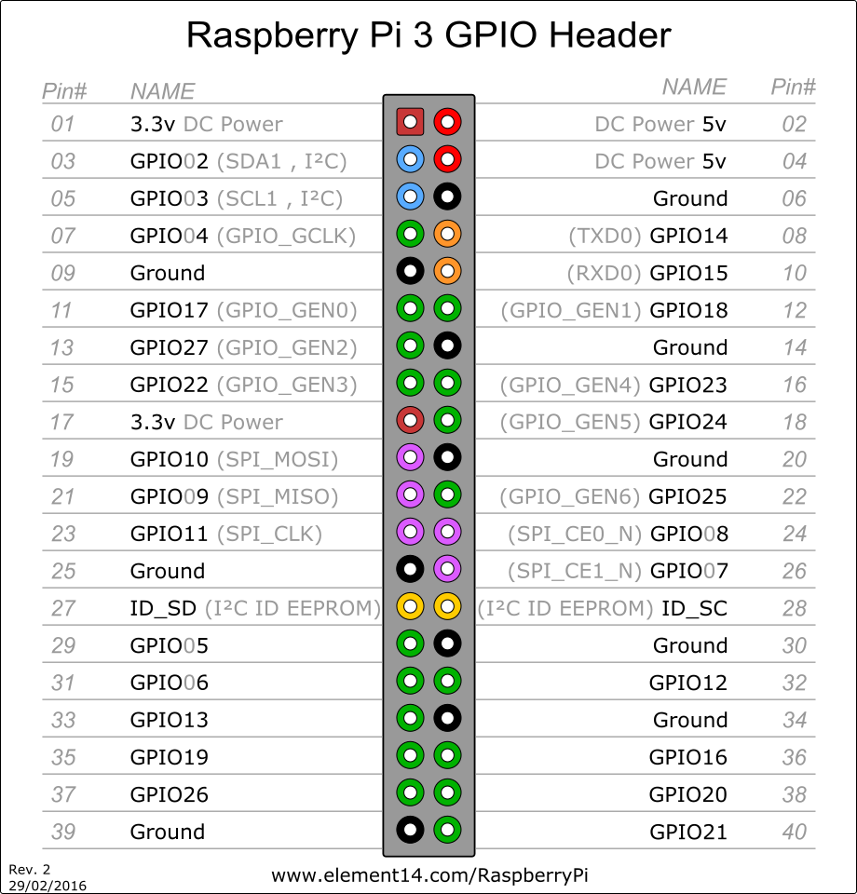

### 5.2.2 Application Notes

GPIO pins can be configured as either general-purpose input, general-purpose output or as one of up to 6 special alternate settings, the functions of which are pin-dependant.

There are 3 GPIO banks on BCM2835.

Each of the 3 banks has its own VDD input pin. On Raspberry Pi, all GPIO banks are supplied from 3.3V. **Connection of a GPIO to a voltage higher than 3.3V will likely destroy the GPIO block within the SoC.**

A selection of pins from Bank 0 is available on the P1 header on Raspberry Pi.

GPIO Pads

The GPIO connections on the BCM2835 package are sometimes referred to in the peripherals datasheet as "pads" - a semiconductor design term meaning "chip connection to outside world".

The pads are configurable CMOS push-pull output drivers/input buffers. Register-based control settings are available for

* Internal pull-up / pull-down enable/disable
* Output [drive strength](http://www.scribd.com/doc/101830961/GPIO-Pads-Control2)
* Input Schmitt-trigger filtering

Power-On States

All GPIOs revert to general-purpose inputs on power-on reset. The default pull states are also applied, which are detailed in the alternate function table in the ARM peripherals datasheet. Most GPIOs have a default pull applied.

Interrupts

Each GPIO pin, when configured as a general-purpose input, can be configured as an interrupt source to the ARM. Several interrupt generation sources are configurable:

* Level-sensitive (high/low)
* Rising/falling edge
* Asynchronous rising/falling edge

Level interrupts maintain the interrupt status until the level has been cleared by system software (e.g. by servicing the attached peripheral generating the interrupt).

The normal rising/falling edge detection has a small amount of synchronisation built into the detection. At the system clock frequency, the pin is sampled with the criteria for generation of an interrupt being a stable transition within a 3-cycle window, i.e. a record of "1 0 0" or "0 1 1". Asynchronous detection bypasses this synchronisation to enable the detection of very narrow events.

Alternative Functions

Almost all the GPIO pins have alternative functions. Peripheral blocks internal to BCM2835 can be selected to appear on one or more of a set of GPIO pins, for example the I2C busses can be configured to at least 3 separate locations. Pad control, such as drive strength or Schmitt filtering, still applies when the pin is configured as an alternate function.

### 5.2.3 Trade off Studies

|  |  |  |  |  |  |
| --- | --- | --- | --- | --- | --- |
| **Visual Human Machine interface (I/F 1):** | | | |  |  |
|  | **LCD Screen** | **LED's** | **7-Segment** |  | **Weight** |
| **Cost** | 3 | 10 | 7 |  | 0,5 |
| **Reliability** | 6 | 9 | 7 |  | 0,3 |
| **Ease of use** | 6 | 7 | 6 |  | 0,2 |
|  | 4,5 | 9,1 | 6,8 |  |  |
|  |  |  |  |  |  |
| **Input Human Machine interface (I/F 1):** | | | |  |  |
|  | **Remote** | **Turn key** | **Keypad** |  | **Weight** |
| **Cost** | 1 | 5 | 9 |  | 0,5 |
| **Reliability** | 2 | 2 | 8 |  | 0,3 |
| **Ease of use** | 7 | 9 | 6 |  | 0,2 |
|  | 2,5 | 4,9 | 8,1 |  |  |
|  |  |  |  |  |  |
| **5V Voltage regulator** | |  |  |  |  |
|  | **LM7805** | **LM371** | **usb1002** |  | **Weight** |
| **Efficiency** | 3 | 4 | 8 |  | 0,5 |
| **Cost** | 8 | 8 | 7 |  | 0,2 |
| **Reliability** | 7 | 8 | 9 |  | 0,3 |
|  | 5,2 | 6 | 8,1 |  |  |

### 5.2.4 Design Drawings:

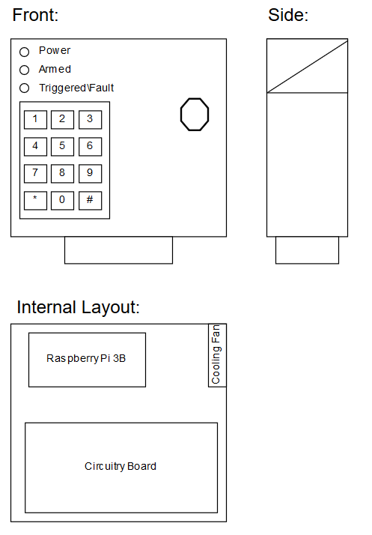

### 5.2.5 Behavioural Modelling:

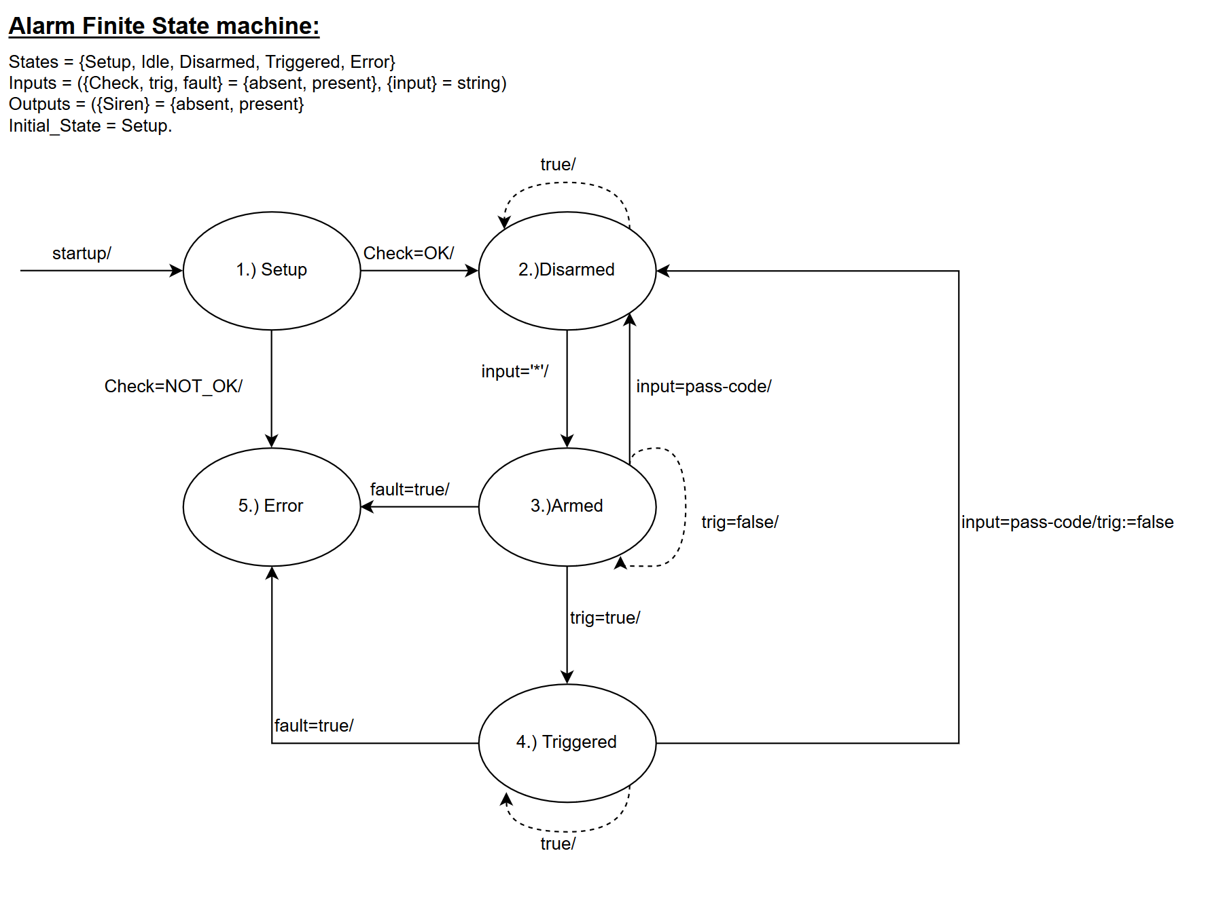

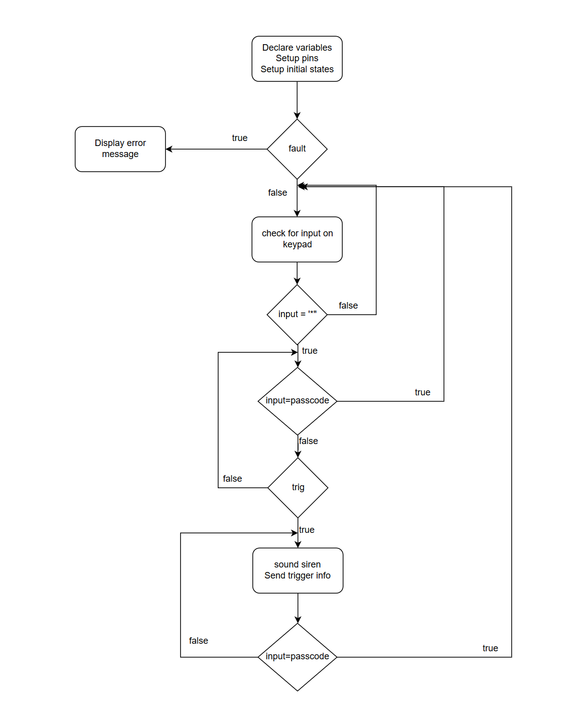

### 5.2.6 Design implementation:

Final construction of Alarm Panel:

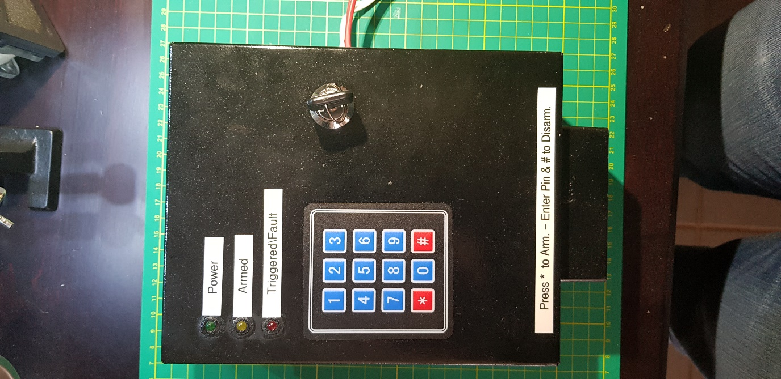

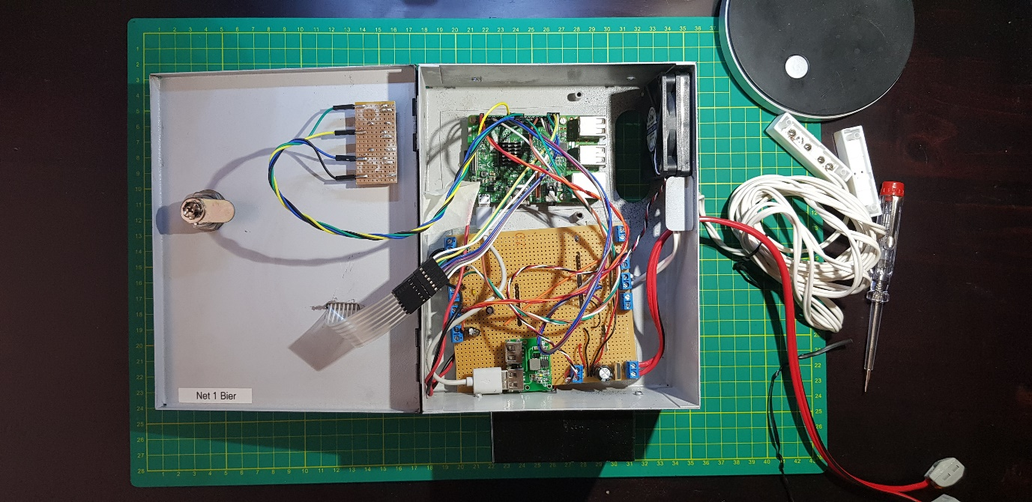

### 5.2.7 Sub-system Test and Evaluation:

|  |  |  |
| --- | --- | --- |
| Action | Expected Results | ✓/🗶 |
| Program started | Terminal shows program has started and heartbeat signal is shown on the power status LED | ✓ |
| Buttons are Pressed on the Keypad | Terminal shows the button pressed | ✓ |
| The “*” button is pressed in idle mode to enter armed Mode | The terminal displays that the system is arming, when the system is armed the terminal will display armed, and a heartbeat signal will show on the Armed status LED | ✓ |
| Moving the reed switch while in armed mode | The siren starts ringing. The terminal displays a trigger on the Reed sensor. The Triggered status LED starts flashing | ✓ |
| Moving the PIR sensor while in armed mode | The siren starts ringing. The terminal displays a trigger on the PIR sensor. The Triggered status LED starts flashing | ✓ |

|  |  |  |
| --- | --- | --- |
| Action | Expected Results | ✓/🗶 |
| Power up | The system run through the setup phase and the heartbeat signal is shown on the power status LED. The system is then in the idle state. |  |
| The “*” button is pressed in idle mode to enter armed Mode | A buzzer will start sounding and after 5 second the system will enter the armed state. A heartbeat signal will show on the Armed status LED |  |
| Moving the reed switch (DCS) while in armed mode | The Triggered status LED starts flashing. The user is then given time to disarm the system. After the time has elapsed (20 seconds) and no passcode has been entered or the incorrect passcode has been entered. The siren starts ringing. A UDP message is sent showing a Door switch trigger has occurred |  |
| Disarming the system when the Reed Switch (DCS) has been triggered | The system turns of the armed status LED, and the Triggered status LED. Thereafter the system returns to the idle state |  |
| Triggering the PIR sensor while in armed mode | The siren starts ringing. The Triggered status LED starts flashing. A UDP message is sent showing a PIR sensor trigger has occurred |  |
| Enter the passcode + “#” while in armed state | The system turns of the armed status LED and returns to the idle state |  |
| Enter the passcode + “#” while in triggered state | The system turns of the triggered status LED and returns to the idle state |  |

## 5.3 Sub-system Design Documentation FJ Fourie:

### 5.3.1 Technology Survey/Datasheets

Datasheets in separate PDF

### 5.3.2 Application Notes

Application notes in separate PDF

### 5.3.3 Trade off Studies

|  |  |  |  |  |  |
| --- | --- | --- | --- | --- | --- |
| **Programming Language** | | | |  |  |
|  | **QT** | **IDLE** | **Matlab** |  | **Weight** |
| **Ease of use** | 8 | 6 | 7 |  | 0,2 |
| **Available information** | 8 | 9 | 10 |  | 0,3 |
| **Functionality** | 10 | 7 | 8 |  | 0,5 |
|  | 9 | 7,4 | 8,9 |  |  |
|  |  |  |  |  |  |
| **Database program bundles** | | | |  |  |
|  | **Oracle Database** | **XAMPP** | **MYSQL** |  | **Weight** |
| **Ease of use** | 7 | 10 | 9 |  | 0,2 |
| **Available information** | 6 | 8 | 9 |  | 0,3 |
| **Functionality** | 8 | 9 | 10 |  | 0,5 |
|  | 7,2 | 8,9 | 9,5 |  |  |

### 5.2.4 Design Drawings:

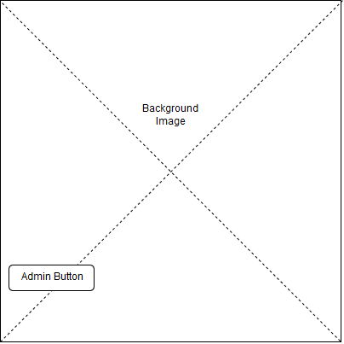

Figure : Back end initial screen concept

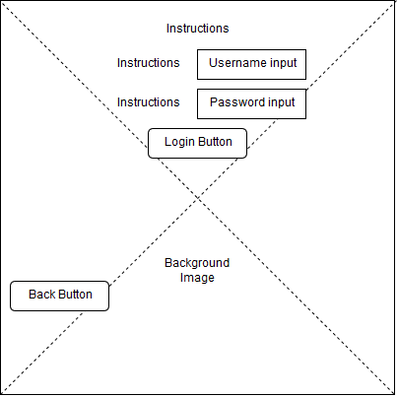

Figure : Admin login screen concept

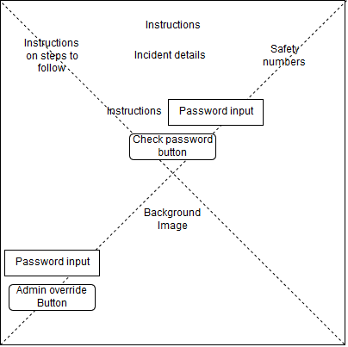

Figure : Incident display screen concept

### 5.2.5 Behavioural Modelling:

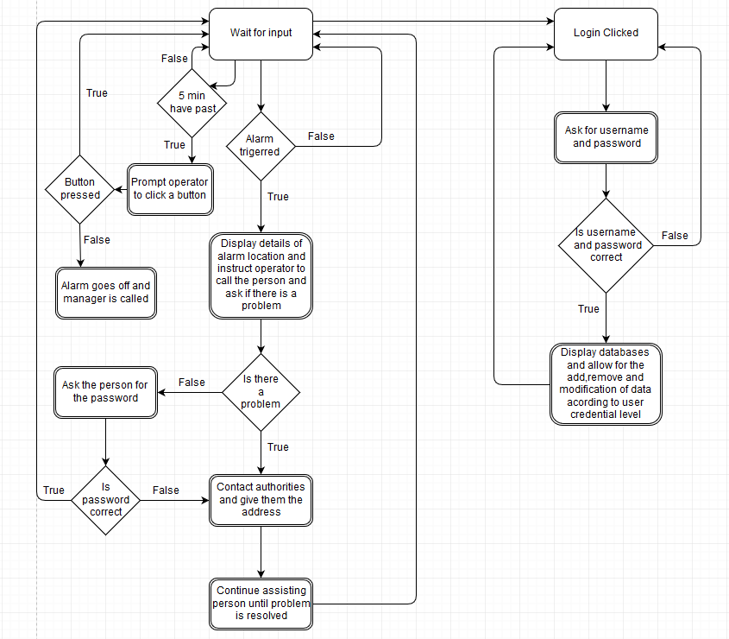

### 5.2.6 Design implementation:

Screenshots from backend program that has been made from the design drawings above.

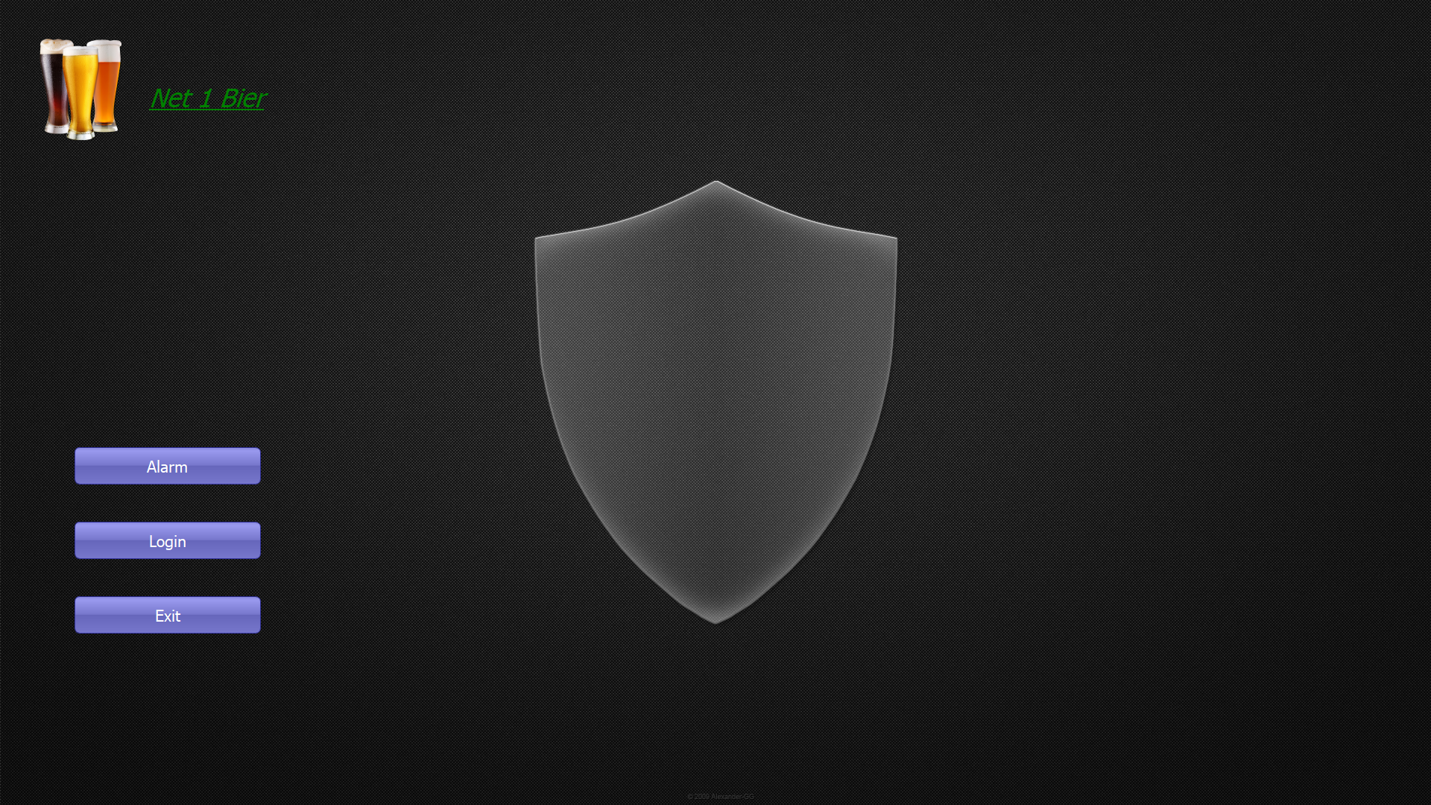

Figure : Back end initial screen

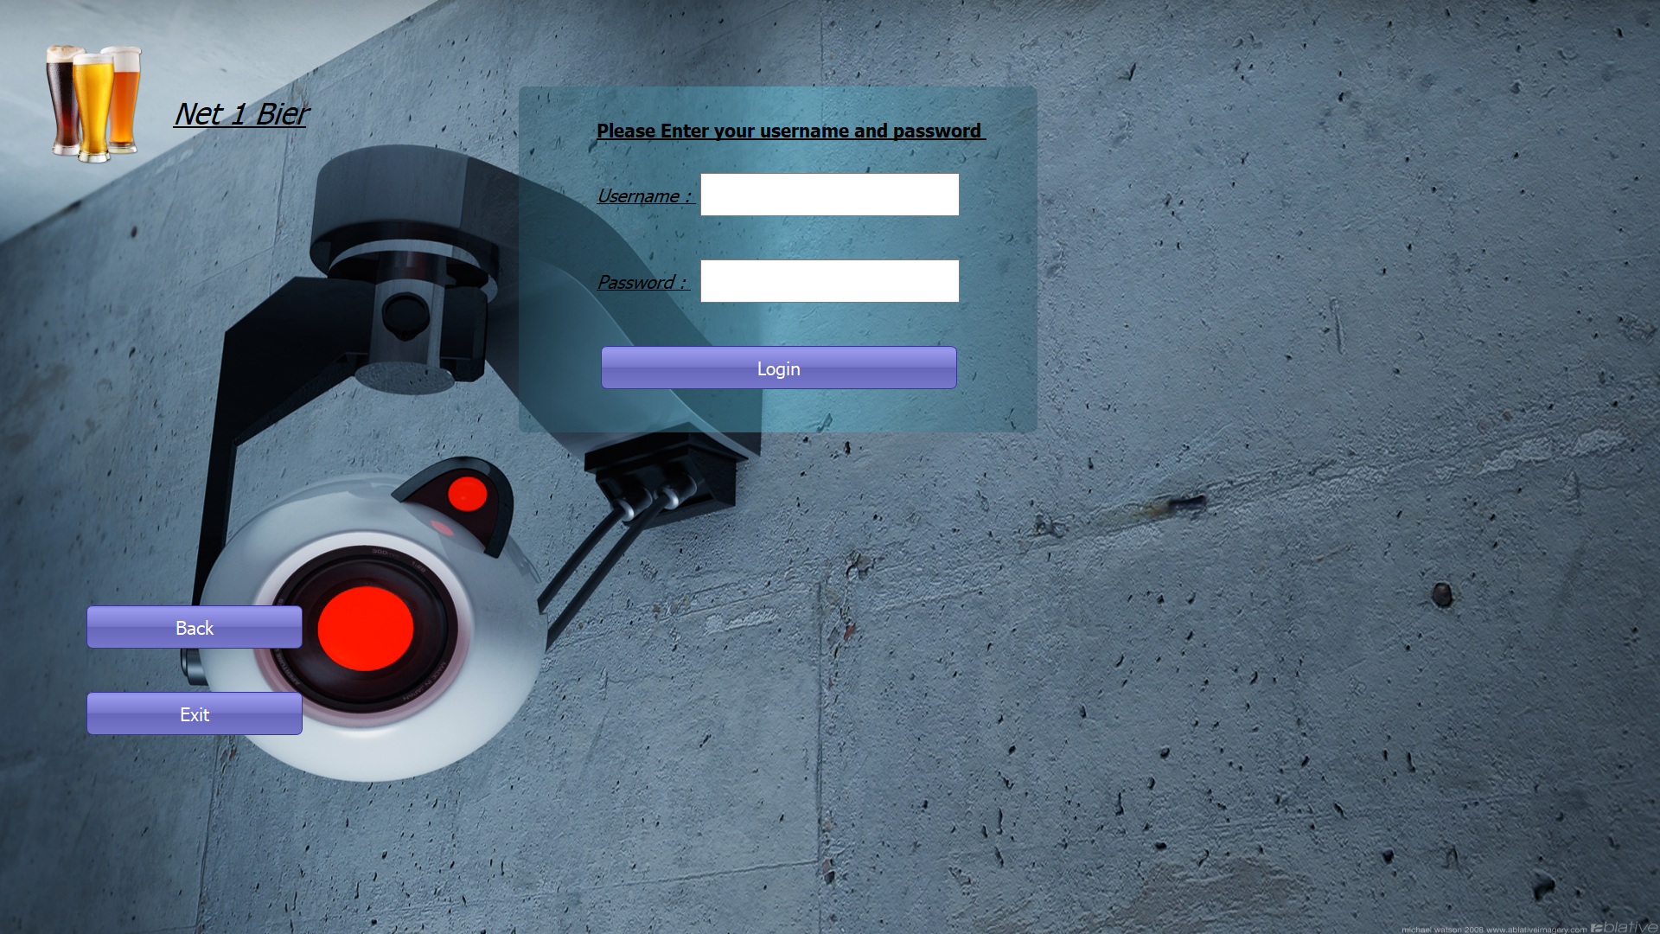

Figure : Admin login screen

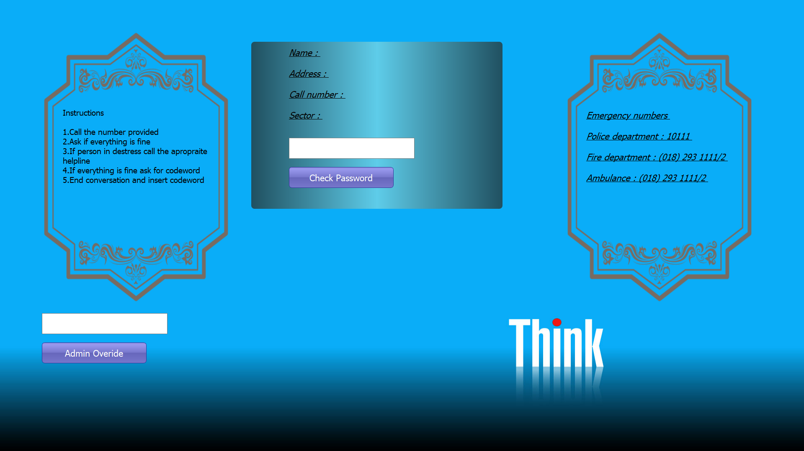

Figure : Incident display screen

### 5.2.7 Sub-system Test and Evaluation:

|  |  |  |
| --- | --- | --- |
| Action | Expected Results | ✓/🗶 |
| Program started | Displays screen that cannot be exited can only navigate to admin login screen | ✓ |
| Login Pressed | When button is pressed navigate to admin login screen | ✓ |
| Incident occurs | If an incident occurs immediately open the incident window with no possibilities of closing it or going back | ✓ |
| Admin check login button pressed | Checks if admin user credentials are correct before giving him access to the database | ✓ |
| Admin Override pressed | Checks if admins override password is correct and if correct close incident | ✓ |
| Password check pressed | If the password typed in is the users correct passcode close the incident | ✓ |